**Assignment 1.2 [ input statement and operators ]**

1. Write a python program to take a input in uppercase and change it to lower case.

Solution:-

ch=input("Enter characters in uppercase: ")

print("Lowercase of given character is ",ch.lower())

Output:-



1. Write a python program to input the radius of a circle and print its area and perimeter.

Solution:-

rad=float(input("Enter radius of circle: "))

area=3.14*rad*rad

peri=2*3.14*rad

print("Area of circle: ",area,"\nPerimeter of circle: ",peri)

Output:-



1. Write a python program to input marks in 5 subjects of a student and print its average mark.

Solution:-

m= float(input("Enter mark of maths subject: "))

e= float(input("Enter mark of english subject: "))

ss= float(input("Enter mark of social science subject: "))

sc= float(input("Enter mark of science subject: "))

cs= float(input("Enter mark of computer subject: "))

sum=m+e+ss+sc+cs

avg=sum/5

print("Average mark: ",avg)

Output:-

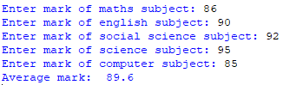

1. Write a python program to input a number and print its square, cube and fourth power.

Solution:-

num=int(input("Enter a number: "))

print("Square of given number: ",pow(num,2),

"\nCube of given number: ",pow(num,3),

"\nFourth of given number: ",pow(num,4))

Output:-

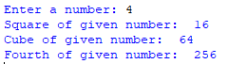

1. Write a python program to input the sides of a triangle and print its area.

Solution:-

a=float(input("Enter first side of a triangle: "))

b=float(input("Enter second side of a triangle: "))

c=float(input("Enter third side of a triangle: "))

s=(a+b+c)/2

area=(s*(s-a)*(s-b)*(s-c)) ** 0.5

print("Area of triangle: ",area)

Output:-

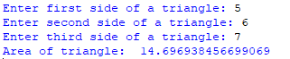

1. Write a python program to compute SI and CI.

Solution:-

p=float(input("Enter the principal amount: "))

r=float(input("Enter the rate of interest: "))

t=float(input("Enter the time: "))

SI=(p*r*t)/100

CI=p*(1+r/100)**t - p

print("Simple Interest: ",SI,"\nCompound Interest: ",CI)

Output:-

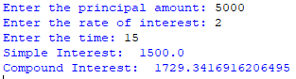

1. Ask the user to enter a number x. Use the sep optional argument to print out x, 2x, 3x, 4x,and 5x, each separated by three dashes, like below.

Enter a number: 7

7---14---21---28---35

Solution:-

n=int(input("Enter a number: "))

print((n*1),(n*2),(n*3),(n*4),(n*5),sep='---')

Output:-

